BOREHOLE RESTORE
Non-toxic, Non-Corrosive Pipe work and Bore Cleaner
Safe Water Technology
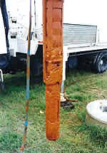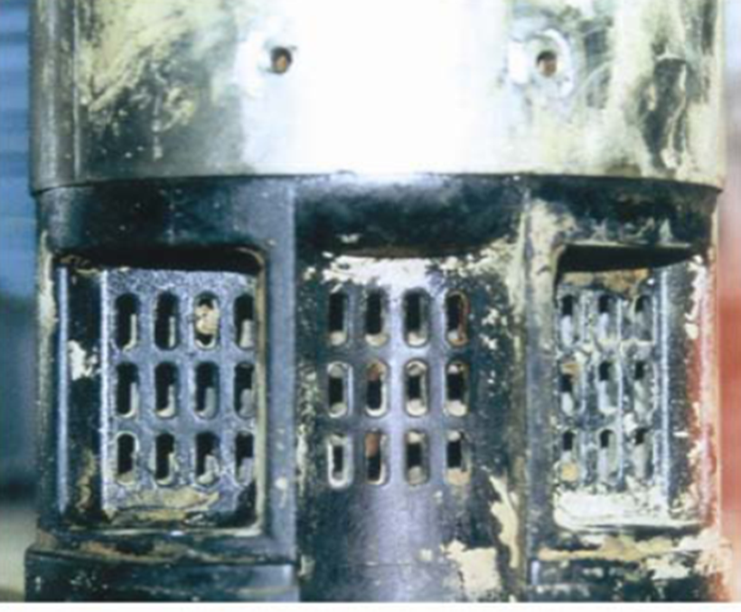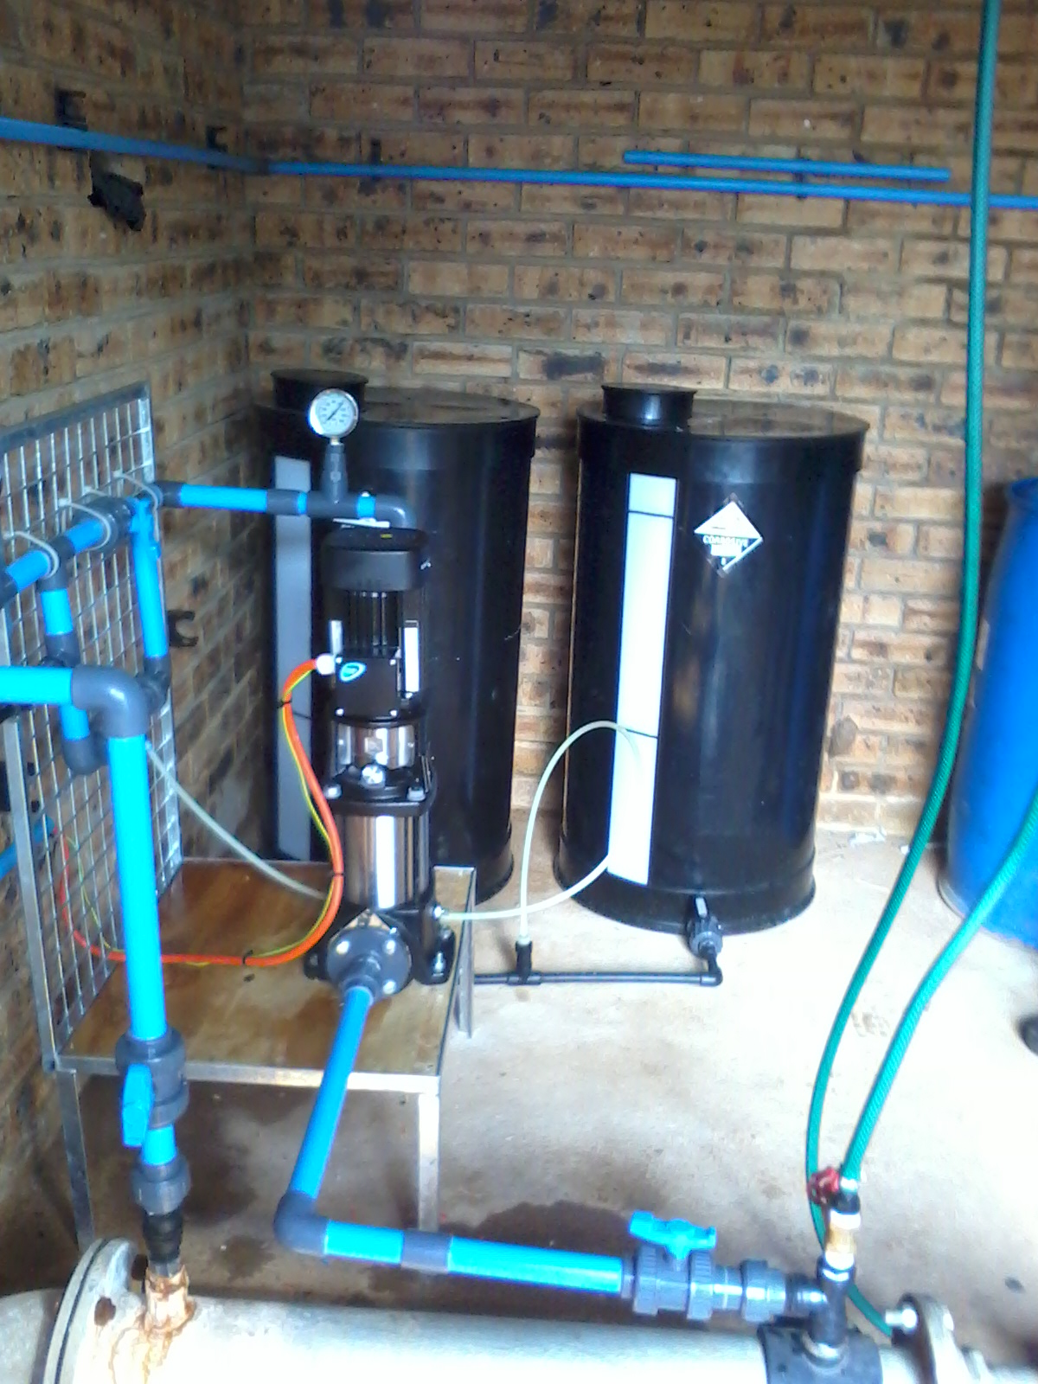

Your pipe work and bore cleaner for effective and safe removal of iron bacteria

Description Bore- Restore is a high performance patented chemistry used to remove iron bacteria from water bores, pipes, pumps and filters. The product also controls scum, slime and algae growth. Bore-Restore is suitable for use in organic production carries numerous approvals for use in water supply for drinking water including SABS National Standard SANS 52671:2007 Chemicals used for treatment of water for human consumption-CLO2

